(BE-2014) CSE
MANUAL FOR PREPARATION OF INTEGRATED PROJECT REPORT

(Prescribed Format and Specifications)

GENERAL INTRODUCTION:

This document aims to guide students in preparation of final project report of Integrated Project process. It contains information on the stages of the project, indicating when reports are due, how to get something made up in the work shop and most importantly how to write concise and legible documents with good literary style, presentation and layout. It is important to note that each report must be original. Remember irrelevant information and trivial statements are of no value. It is important not to underestimate the amount of time it takes to write the report.

The manual is intended to provide broad guidelines to in the preparation of the integrated project report. In general, the project report, in an organized and scholarly fashion, is an account of original work of the students leading to techniques or correlation of facts already known (analytical, experimental, hardware oriented etc) and demonstrating definite contribution to the advancement of knowledge and the student ability to present the findings in an appropriate manner with actual accomplishments of the work plainly stated and honestly appraised.

Project reports generally follow the typical structure of scientific and technical research reports: Introduction, Methods, Results, Conclusions, and Recommendations. Although other formats are acceptable, most readers anticipate this format and get their bearings most quickly when it is followed. The following template adopts this standard organizational structure. The headings are those recommended for your own Project Report, but you may have to make occasional deviations from this template to adapt to the needs of your own project.

NUMBER OF COPIES TO BE SUBMITTED FOR EVALUATION:

The candidate’s group is required to prepare two copies of the report and one soft copy in CD, which he/she is required to submit to the Computer Science and Engineering Departmental Office on the day of Evaluation. The report must be prepared strictly in accordance with the specifications set out below.

ARRANGEMENT OF CONTENTS OF PROJECT REPORT:

The sequence in which the training report material should be arranged and bound should be as follows:
- i. Cover page (sample copy attached as annexure-A).
- ii. Title page (sample copy attached as annexure-B).

- iii. Certificate (sample copy attached as annexure-C).

- iv. Declaration (sample copy attached as annexure-D)

- v. Abstract (A brief summary about the project with keywords)
- vi. Acknowledgment (sample copy attached as annexure-E)
- vii. Contents with title & subtitle, page no. (Breakup of sections according to explanation is advised).

- viii. List of Figures

- ix. List of Tables (if any)

- x. Notations(if any)

- xi. Executive summary (with Chapters & sections as annexure-F)

- xii. Appendix / Annexure/References*( if any)

MANUAL FOR PREPARATION OF INTEGRATED PROJECT REPORT 1 | P a g e

(BE-2014) CSE

TEXT PROCESSING INFORMATION

It is important to note that type format of all reports should be uniform. So there is a need to follow some guidelines on typesetting and other aspects. Some of such guidelines are given below.

- 1. The report shall be typed on 75 or 80 gr. /m2 white paper. Size of paper shall be A4.

- 2. Only Laser printer and Ink Jet printer outputs are acceptable to maintain clear and high contrast constant density copy throughout the report.

- 3. As a character font, one should use Times New Roman, Courier, Helvetica or equivalent which are available in most word processors. The font size must be 12 point in the text and at least 8 point in the figures.

- 4. Whenever titles and headings are to be centered the centering shall be such that 112 mm. from the left edge of the paper or 98 mm. for the right edge of the paper is the center point of the title or heading.

- 5. Margins of pages shall conform to the following specifications.

  - a. Left margin - 3 1/2 cm. from edge of paper.

  - b. Right margin - 2 cm. from edge of paper.

  - c. Top margin - 3 1/2cm. from edge of paper.
  - d. Bottom margin - 2 cm. from edge of paper.

The above margins shall be observed on charts, graphs, tables, and drawings. Folded papers will not be accepted unless there is absolutely no other way for the material to be presented.
  - 6. Spacing of the text material shall be 1.5 with the following exceptions:
  - a. Footnotes - single spacing

  - b. Long biographical quotes - single spacing
  - c. Extensive quotations - single spacing and indented eight (8) spaces relative to the text

material.

  - 7. Headings used in the report shall conform to the following rules:

  - a. Chapter Headings - CHAPTER 1, CHAPTER 2, CHAPTER 3 etc.

      - (1) Must begin a new page and be centered using the Font Size 18 with Bold Fold. Omit period at the end of the heading.
      - (2) Must be typed in upper case letters.

      - (3) Chapter headings are to be titled names that reflect content of the text that follows.

  - b. Second Headings - 2.1, 2.2, 2.3, etc.

    - (1) Must be towards left margin and be typed in capital and lower case letters; i.e., the first letter of each word except conjunctions, prepositions, and articles must be a capital letter. Omit period at the end of heading.

    - (2) The letter designation of the heading shall be followed by a period and two blank spaces.

    - (3) Must be three spaces below preceding text and two spaces ahead of succeeding text.

    - (4) Font Size to be used is 14 with Bold Face.

    - (5) In case it is found that first line of the succeeding text starts from the next page, then this heading should start from the next page using page break.

    - 8. Figures and Tables: Ideally, every result claimed in the text should be documented with data, usually data presented in tables or figures. If there are no data provided to support a given statement of result or observation, one should consider adding more data, or deleting the unsupported "observation." Examine figure(s) or table(s) pertaining to the result(s).

MANUAL FOR PREPARATION OF INTEGRATED PROJECT REPORT 2 | P a g e

(BE-2014) CSE

Authors should assess whether:
    - 1. The data support the textual statement

    - 2. The data contradict the textual statement

    - 3. The data are insufficient to prove

The actual figures and tables should be embedded/inserted in the text, generally on the page following the page where the figure/table is first cited in the text. All figures should be numbered and cited consecutively in the text as Figure 2.1, Figure 2.2, to indicate the first and second figures in Chapter 2 respectively. Similarly it is the case with tables such as Table 3.1, Table 3.2, etc. A caption for each figure and table is to be given with proper citation about reference, data sources, etc. and by highlighting the key findings. One should include an index figure (map) showing and naming all locations discussed in the report. Author is always encouraged to make his own figures, including cartoons, schematics or sketches that illustrate the derived processes. He should see all his figures keeping in mind that:

    - 1. Each figure is self-explanatory.
    - 2. Axes of figures are labeled and the units, if used, are indicated.

    - 3. Uncertainty is shown in data with error bars.
    - 4. Redundant data ink must be eliminated.

    - 5. An effort has to be made to increase data density by eliminating non-data bearing space.

    - 6. Whether data is sparse set that could better be expressed as a table.

    - 7. Whether the figure distorts the data in any way.

    - 8. Whether the data are presented in context.

Figures should be oriented vertically, in portrait mode, wherever possible. If they must be oriented horizontally, in landscape mode, so that one can read them from the right, not from the left, where the binding will be.

9. Pagination: Each page in the report or dissertation is expected to bear a number. Only one side of the paper may be used. The following plan should be used exclusively:

a. The preliminary section, including the title page; copyright page, if any; foreword, preface, or acknowledgements; table of contents; etc., should be numbered, using lower case Roman Numerals, e.g., i, ii, iii, etc. The title page counts as Page i, but the number does not appear. The sequence of the

preliminary section is as follows:
Title Page........................................................ Page i - number does not appear

Declaration...................................................... Page ii
Certificate........................................................ Page iii

Acknowledgements......................................... Page iv
Abstract........................................................... Page v

Table of Contents........................................... Page vi
List of Tables.................................................. Page vii

List of Figures................................................. Page viii
List of Symbols.............................................. Page ix

For the remainder of the report, numbers are used. Each page must be numbered. Page numbers are to be placed 2 centimeters from the top and right hand margins on the pages. All pages for illustrations, tables, appendices, bibliography, etc are included. Use of suffixes, such as 25a, 25b ...is not allowed. The numbering in the main body should begin with Page 1 and run consecutively to the last page. No punctuation, such as dash or a period, should accompany the page number.

MANUAL FOR PREPARATION OF INTEGRATED PROJECT REPORT 3 | P a g e

(BE-2014) CSE

    - 11. Size of Report: The project report should be complete in all respect. However it is expected that the number of pages in the report will range 40-50 pages of typed matter reckoned from the First page of Chapter 1 to the last page of the Appendix.

    - 12. Binding Specifications:

The project must be Black Card-board Bounded with Lamination Sheet. (Spiral binding and other forms of binding will not be accepted)

PREPARATION FORMAT:

This section explains the purpose and contents of each section of the Report.

Cover

The Cover should contain the title of the project, followed by the date of submission, and then followed by the names and affiliations of the submitters, all of which should be centered in the page. The Cover may be printed on colored paper of slightly heavier stock.

Title Page
Use a format similar to those used for project update presentations.

Abstract

The Abstract is a succinct statement that comprises the essential content of the Project Report. It will be technical in nature, intended for reading by an engineer or computer scientist. The Abstract summarizes the results of the design project without explaining why design decisions were made, or justifying the findings.

Acknowledgments

The Acknowledgments should recognize the assistance given by the liaison at the sponsoring company, the project faculty advisor, the institutional support, and any other individuals who rendered significant assistance.

Table of Contents, List of Figures, List of Tables

The Table of Contents, List of Figures, and List of Tables should be self explanatory, and most modern word processors can generate them for you.

INTRODUCTION

Statement of the Problem

This section can usually be reproduced directly from your proposal, completed at the end of fall term. The purpose of this section is to listen to the needs of the sponsoring company and to show that you understand the problem from their perspective.

Background

This section, too, can be taken directly from your proposal unless new or revised information gives you a reason to change it.

Purpose of Project and Overview of Project Report

Summarize the purpose of your project in one or two sentences: “The purpose of this project was to develop an effective means of solving problem ABC by designing device XYZ.” Your purpose statement is simply an expansion of your title into sentence format. Following your purpose statement, give a

MANUAL FOR PREPARATION OF INTEGRATED PROJECT REPORT 4 | P a g e

(BE-2014) CSE

statement which describes the shape or structure of the rest of the Project Report. When readers can anticipate the shape of what is coming they can devote full attention to the content. This section follows the advice “Lay out the whole before presenting the parts.”

METHODS AND DESIGN APPROACH

Your purpose in this section is to show the logic in the way that your team attacked the problem. Your goal here is to explain the sequence of problem-solving steps that your team went through. Show your clear engineering thinking when describing your methods.

RESULTS

The purpose of this section is to describe in detail the actual device or product you produced. The number of subheadings of this section depends on the complexity of your product and on the kinds of information that you think your sponsoring company will need to know. Group your explanations by category and give each category a clarifying heading. Here are some typical headings that will fit most projects.

Specifications
Tell what your device does at what levels of precision.

Construction Methods

Explain how your device is made, what its materials are, etc.

Operation
Explain how your device works; make your instructions clear to a new user.

Testing and Calibration
How did you test your device and how did you calibrate it?

External Constraints

The report must address economic, environmental, sustainability, manufacturability, ethical, health and safety, social, and political constraints of the project.

CONCLUSIONS

From a managerial standpoint, this is probably the most important section of your Project Report. Technical and business managers frequently read this section of the Project Report first even though it comes near the end of the document! Your goal here is to evaluate your original criteria. How well does your product actually work? Does it solve the problem that the company wanted solved? Be candid and honest here. What are the weaknesses and limitations of your product? What parts of the original problem were more difficult than anticipated? What hopes for your solution didn’t turn out?

In short, this section may say, “We solved part of your problem but not other parts,” or “Our solution finally didn’t work, and we didn’t solve your problem at all.”

The people who read the Conclusions and Recommendations sections of your Project Report are power people inside their company! In light of your conclusions, what recommendations do you have for the company? Should they begin immediate production of your prototype? Should they do further testing of your prototype? Should they put out an RFP for further research? Should they do a market study? Should they look for more cost effective ways of building a device similar to your prototype? Much of your future reputation as a design team rests on recommendations.

MANUAL FOR PREPARATION OF INTEGRATED PROJECT REPORT 5 | P a g e

(BE-2014) CSE

REFERENCES
Follow the Project Proposal guidelines.

APPENDICES

Appendices can follow where you did in the original proposal with suggestions from your faculty advisor.

FORMAT OF CD CONTAINING SOFTWARE AND REPORT

Each software/Project developed by the Project's Group should be burnt in a CD with proper documentation. The CD should contain files containing the source code, one or more sample input and corresponding output separately. Other than these there must be another file named "READ.ME". In this ASCII text file, the following sections must be appear.

Author's Group Identity - A file should contain the name of each project group member along with the Supervisor's name.

Files in the CD - In this section, the names of the files together with their contents must be listed. Hardware Requirements - In this section, we should note down the hardware requirements along with any special type of equipments/ components such as graphics card, numeric coprocessor, mouse, RAM capacity etc. needed to run the software.

Software Requirements - In this section, the operating system, the compiler, linker, and the libraries etc. necessary to compile and link the software must be listed. There is a need to obtain the necessary license from the copyright owner before one incorporates the copyrighted material file in CD.

MANUAL FOR PREPARATION OF INTEGRATED PROJECT REPORT 6 | P a g e

(BE-2014) CSE

(Annexure A)

INTEGRATED PROJECT REPORT

On

GLUTTONOUS SNAKE

Submitted in partial fulfillment of the requirement for the
Course Integrated Project (CSP2208) of

COMPUTER SCIENCE AND ENGINEERING
B.E. Batch-2014

in

May-2016

Under the Guidance of | Submitted By
Mr. Nitin Goel | Akash Deep Mishra
Designation of the Project Guide | Roll. No.-1410991042
 | Akhilesh Sharda
 | Roll. No.-1410991047
 | Akshit Matta
 | Roll. No.-1410991056
 | Amandeep
 | Roll. No. -1410991062

SCHOOL OF COMPUTER SCIENCES
CHITKARA UNIVERSITY
PUNJAB

MANUAL FOR PREPARATION OF INTEGRATED PROJECT REPORT 7 | P a g e

(BE-2014) CSE

(Annexure B)

INTEGRATED PROJECT REPORT

On

GLUTTONOUS SNAKE

Submitted in partial fulfillment of the requirement for the
Course Integrated Project (CSP228) of

COMPUTER SCIENCE AND ENGINEERING
Batch-2014

in

May-2016

Under the Guidance of | Submitted By
Mr. Nitin Goel | Akash Deep Mishra
Designation of the Project Guide | Roll. No.-1410991042
 | Akhilesh Sharda
 | Roll. No.-1410991047
 | Akshit Matta
 | Roll. No.-1410991056
 | Amandeep
 | Roll. No. -1410991062

SCHOOL OF COMPUTER SCIENCES

CHITKARA UNIVERSITY
PUNJAB

MANUAL FOR PREPARATION OF INTEGRATED PROJECT REPORT 8 | P a g e

(BE-2014) CSE
(Annexure –C)

CERTIFICATE
(16 Times New Roman)

This is to be certified that the project entitled “GLUTTONOUS SNAKE” has been submitted for the Bachelor of Computer Science Engineering at Chitkara University, Punjab during the academic semester January 2016- May-2016 is a bonafide piece of project work carried out by“AKASH DEEP MISHRA(1410991042), AKHILESH SHARDA(1410991047), AKSHITA MATTA(1410991056),AMANDEEP(1410991062) towards the partial fulfillment for the award of the course Integrated Project (CSP2208) under the guidance of “NITIN GOEL” and supervision.

Sign. of Project Guide :

Mr. Nitin Goel

(Designation & Department)

MANUAL FOR PREPARATION OF INTEGRATED PROJECT REPORT 9 | P a g e

(BE-2014) CSE
(Annexure –D)

CANDIDATE’S DECLARATION
(16 Times New Roman)

We, NAME AND Roll No’s OF THE STUDENTS GROUP, B.E.-2014 of the Chitkara University, Punjab hereby declare that the Integrated Project Report entitled “GLUTTONOUS SNAKE” is an original work and data provided in the study is authentic to the best of our knowledge. This report has not been submitted to any other Institute for the award of any other course.

Sign. of Student 1 | Sign. of Student 2 | Sign. of Student 3
Akash Deep Mishra | Akhilesh Sharda | Akshit Matta
ID No-1410991042 | ID No-1410991047 | ID No-1410991056

Sign. of Student 4
Amandeep
ID No-1410991062

Place: Chitkara University, Punjab

Date:05-05-16

MANUAL FOR PREPARATION OF INTEGRATED PROJECT REPORT 10 | P a g e

(BE-2014) CSE
(Annexure -E )

ACKNOWLEDGEMENT
(16 Times New Roman)

It is our pleasure to be indebted to various people, who directly or indirectly contributed in the development of this work and who influenced my thinking, behavior and acts during the course of study.

We express our sincere gratitude to all for providing me an opportunity to undergo Integrated Project as the part of the curriculum.

We are thankful to “Project Guide Name” for his support, cooperation, and motivation provided to us during the training for constant inspiration, presence and blessings.

We also extend our sincere appreciation to “Project Guide name and External Guide name (if any) who provided his valuable suggestions and precious time in accomplishing our Integrated project report.

Lastly, We would like to thank the almighty and our parents for their moral support and friends with whom we shared our day-to day experience and received lots of suggestions that improve our quality of work.

Akash Deep Mishra | Akhilesh Sharda | Akshit Matta
ID No-1410991042 | ID No-1410991047 | ID No-1410991056

Amandeep
ID No-1410991062

MANUAL FOR PREPARATION OF INTEGRATED PROJECT REPORT 11 | P a g e

(BE-2014) CSE
(Annexure –F)

The report must consist of following chapters:

    - 1. Abstract/Keywords

    - 2. Introduction to the project

  - 2.1 Background

  - 2.2 Problem Statement

  - 3. Software and Hardware Requirement Specification

  - 3.1 Methods

  - 3.2 Programming/Working Environment

  - 3.3 Requirements to run the application

  - 4. Database Analyzing, design and implementation (If any)

  - 5. Program’s Structure Analyzing and GUI Constructing (Project Snapshots)

  - 6. Code-Implementation and Database Connections (If any)

  - 7. System Testing (if any)

  - 8. Limitations (if any)

  - 9. Conclusion

  - 10. Future Scope

  - 11. Bibliography/References

MANUAL FOR PREPARATION OF INTEGRATED PROJECT REPORT 12 | P a g e
1. Abstract: This project aims to bring the fun and simplicity of snake game with some new features in a new and interesting way . It will include user defined inputs or predefined inputs whose aim will be to challenge the human players or user to come out with highest score possible using dijakshtra algorithm. This project explores a new dimension in the traditional snake game to make it more interesting and challenging. The complexity of this game makes it an ideal candidate for a minor project.

2. Introduction to the project:

2.1 Background:
Nokia's series of Snake games, were immensely popular games with Nokia users. The original, snake, is still considered one of the great, classic games of Nokia. Nokia is well known for putting Snake on most of their phones. The original game, for monochrome phones. Graphics consisted of black squares, and it had 4 directions. An example of a phone with it installed is the Nokia 6110 or the Nokia 3210. It was programmed in 1997 by Taneli Armanto, a design engineer in Nokia. Make sure for achieving highest score make the snake grow longer by directing it to the food. Use the keys 2,4,6 and 8. You cannot stop the snake or make it go backwards. Try not to hit the walls or the tail.

2.2 Problem statement:

Q) Jeff loves playing games, Gluttonous snake (an
old game in NOKIA era ) is one of his favorites’. However, after playing gluttonous snake so many times, he finally got bored with the original rules. In order to bring new challenge to this old game, Jeff introduced new rules: 1. The ground is a grid, with n rows and m columns(1 <= n, m <= 500). 2. Each cell contains a value v (-1 vi 99999), if v is -1, then this cell is blocked, ≤ ≤ and the snake cannot go through, otherwise, after the snake visited this cell, you can get v point. 3. The snake can start from any cell along the left border of this ground and travel until it finally stops at one cell in the right border. 4. During this trip, the snake can only go up/down/right, and can visit each cell only once. Special cases : a. Even in the left border , the snake can go up and down. b. When the snake is at the top cell of one column, it can still go up, which demands the player to pay all current points , then the snake will be teleported to the bottom cell of this column and vice versa. After creating such a new game, Jeff is confused how to get the highest score. Please help him to write a program to solve this problem. Input: The first line contains two integers n (rows) and m (columns), (1 <= n, m <= 500), separated by a single space. Next n lines describe the grid. Each line contains m integers vi (-1 ≤ vi ≤ 99999) vi = -1 means the cell is blocked.

3. Software and Hardware Requirement Specification
  - 3.1 Methods:
  - 3.2 Programming/Working Environment: Codeblocks 13.12
  - 3.3 Requirements to run the application: Min. Pentium r4 with 512 mb Computer System

13| P a g e
- Implementation:

#include <iostream>
#include <cstring>
using namespace std;

int grid[501][501];
bool vis[501][501];
int m, n;
long long ans = -1;
int cx[] = {-1, 0, 1};
int cy[] = {0, 1, 0};

// Use of depth first search
void dfs(long long sum, int x, int y) {
if (y == n - 1 && sum > ans) {
ans = sum;
}
for (int i = 0; i < 3; ++i) {
bool flag = false;
int nx = x + cx[i];
if (nx == -1) {

14 | P a g e

nx = m - 1;
flag = true;
}
if (nx == m) {
nx = 0;
flag = true;
}
int ny = y + cy[i];
if (ny == n) continue;
if (vis[nx][ny] || grid[nx][ny] == -1) continue;// to check for -1 values
vis[nx][ny] = true;
if (flag)
dfs(grid[nx][ny], nx, ny);
else
dfs(sum + grid[nx][ny], nx, ny);
vis[nx][ny] = false;
}
}
int main() {
cout<<"Enter Grid :";
15 | P a g e
cin>>m>>n;
cout<<endl<<"Enter Numbers in the grid:";
for(int i = 0; i < m; ++i)
for (int j = 0; j < n; ++j)
cin>>grid[i][j];
memset(vis, false, sizeof(vis));

for (int i = 0; i < m; ++i) {
if (grid[i][0] == -1)
continue;
vis[i][0] = true;
dfs(grid[i][0], i, 0);
vis[i][0] = false;
}
cout<<endl<<"Highest Score : "<<ans;
return 0;}

16 | P a g e
5. Program’s Structure Analyzing and GUI Constructing

  - 6. Code-Implementation and Database Connections (If any)

7. System Testing (if any)

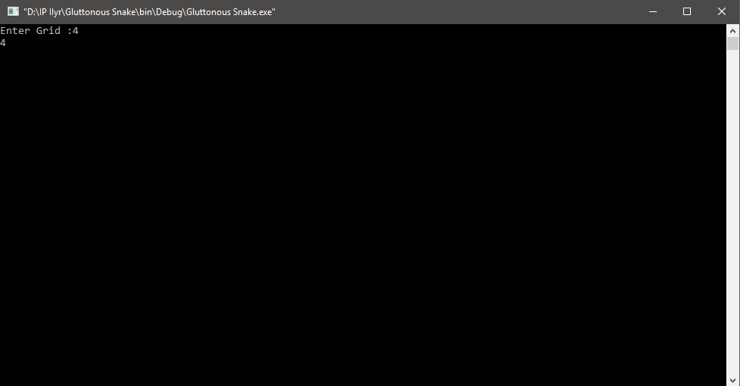

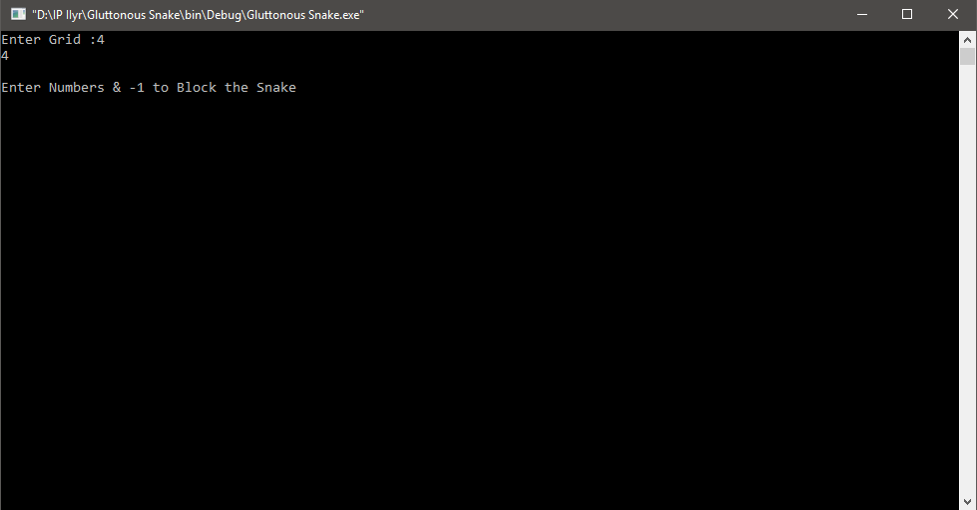

17 | P a g e
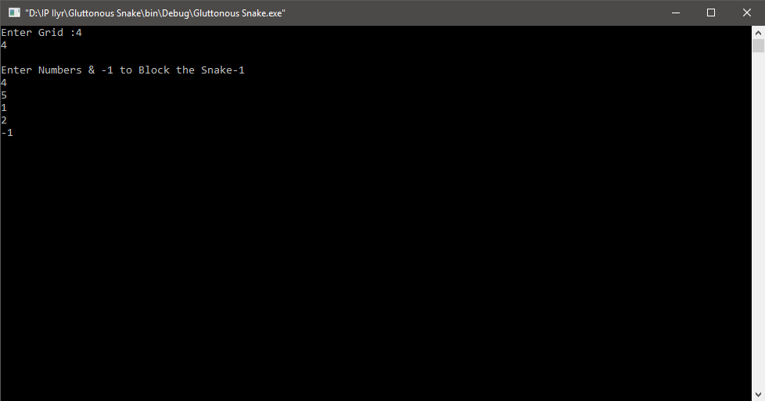

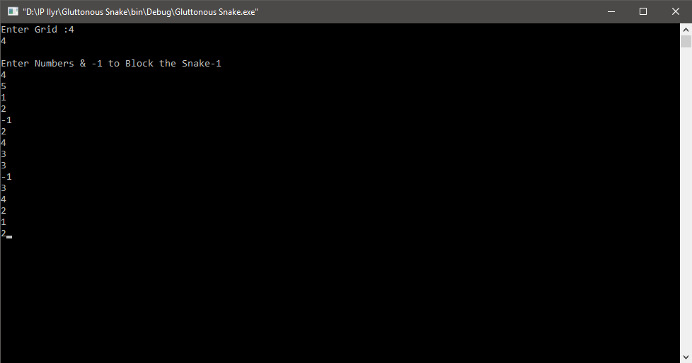

18 | P a g e
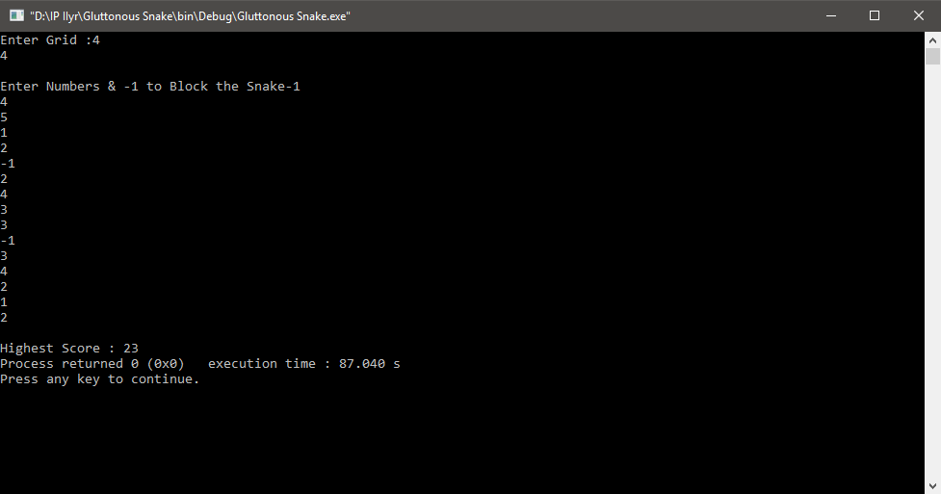

  - 8. Limitations (if any)
This project only has one limitation and that is a lack of real life use. It cannot be used anywhere other than another game. This would have been a perfect project if this algorithm could be used in several other projects as well to if this could have been used in several instances in normal everyday life!!

9. Conclusion
This is an algorithm based on dijakastra i.e shortest path but it has a twist in it. This algorithm calculates the highest score with the shortest path. The algorithm was made due the repetitive and boring nature of its older sibling game ‘the gluttonous snake’. This algorithm changes that since this will now make the user input the length and the values in the grid. The user can make the grid as big as they want and add the values themselves. Therefor the game will not be repetitive anymore hence making it all the more interesting and competitive. this algorithm uses the dijakastra algorithm to calculate the shortest path while additionally calculating the maximum value of input done by the user. This is why it is known as a smart snake because it can see and concur itself which way to go to get the highest score. the snake itself determines the best and the shortest path to get the highest score hence justifying its name of a SMART SNAKE!

19 | P a g e

10. Bibliography/References

www.google.com
www.codechef.com
www.hackerrank.com
www.stackoverflow.com
Nitin Goel(Guide)

